1. INTRODUCTION
   1. Overview

A population is defined as a group of individuals of the same species living and interbreeding within a given area.Members of a population often rely on the same resources,are subject to similar environmental constraints, and depend on the availability of other members to persist over time.

* 1. Purpose

Population are used when your research question requires, or when you have access to , data from every member of the population

1. PROBLEM DEFINITION &

DESIGN THINKING

2.1 Empathy map

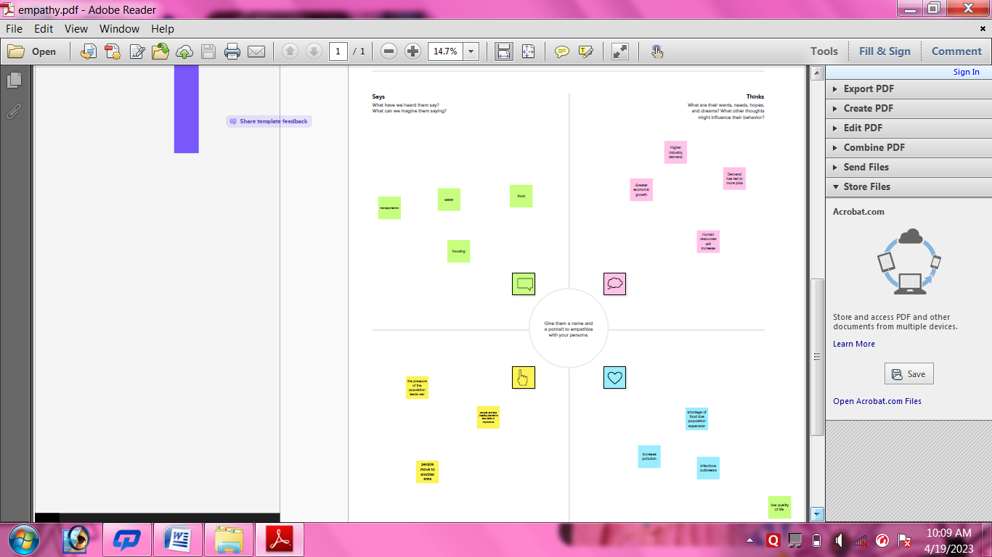

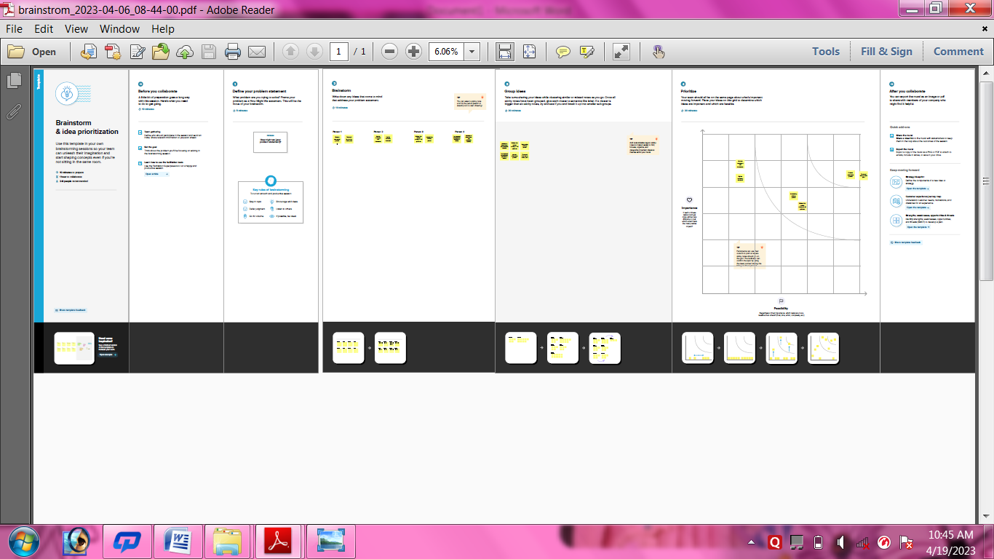

1. RESULT

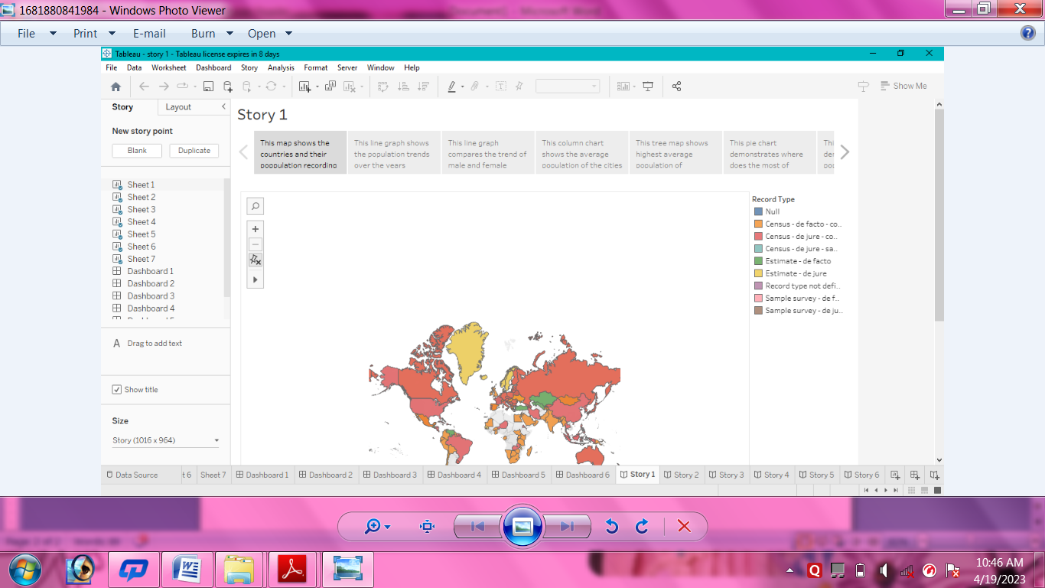

1. ADVANTAGES & DISADVANTAGES

# ADVANTAGES:

1. Diversity will be more

2. Economic growth will be comparatively more than low density area

3. Did not happen food shortages

4. Rising population leads to grater scope

5. Controls population growth

# DISADVANTAGES:

1. Extinction of language , culture, food choices

2. Economy will shrink more unemployment

3. Does not protect from STD

4. Low quality of life

5. Low per capita income

5 APPLICATIONS

1. The knowledge of population genetics is very useful for the genetic improvement of any species . The use (application) of this science of genetics can be viewed as under .

2. The study of the rules governing the maintenance and transmission of genetic variation in natural populations.

6 CONCLUSION

The Earth’s current population is almost 7.6 billion people , and it is expanding. It is expected to surpass 8 billion people by 2025, 9 billion by 2040, and 11 billion by 2100. The population is quickly increasing, far surpassing our planet’s ability to maintain it, given existing habits .

7 FUTURE SCOPE

1. Health care planning
2. Looking at the implications of an ageing population
3. Making national and international comparisons
4. Childcare and schools planning
5. Housing and land use planning

8 APPENDIX

# Source code

1. Github
2. Mural
3. MySQL
4. Tableau
5. HTML